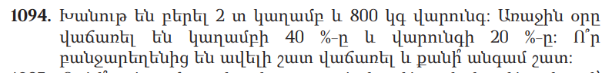

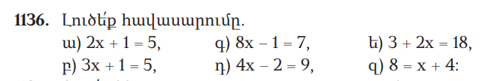

C:\Users\ekatr\OneDrive\Pictures\Screenpresso\2024-03-06_12h02_24.png

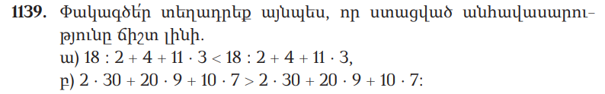

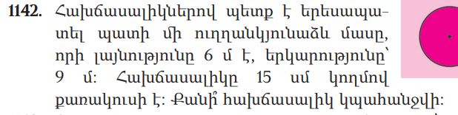

C:\Users\ekatr\OneDrive\Pictures\Screenpresso\2024-03-06_12h04_48.png

